Hash function Introduction.
The idea of the hashing is taking the large keys and use the hash function converting the large keys into small values that can be used as an index in an array(hash table).
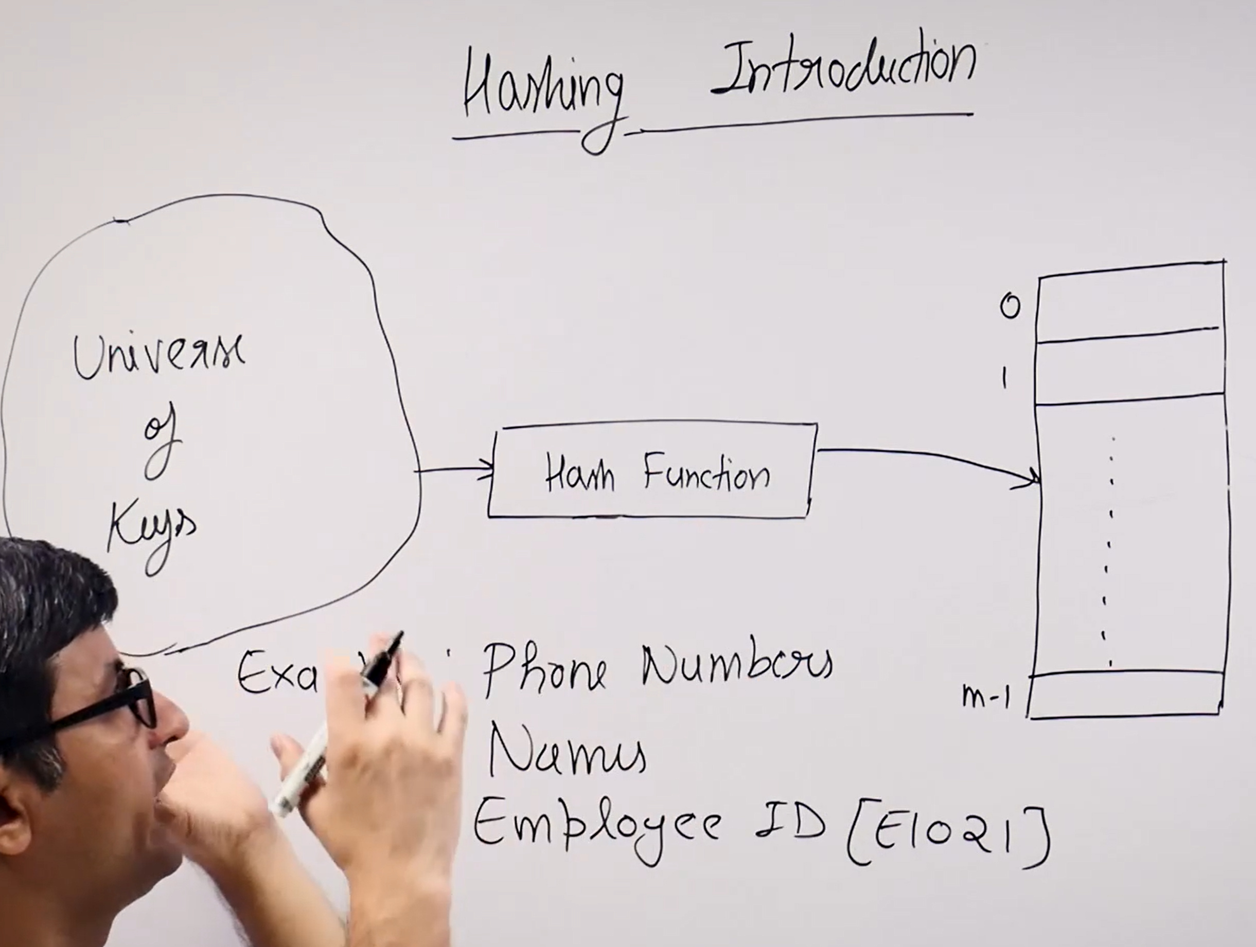
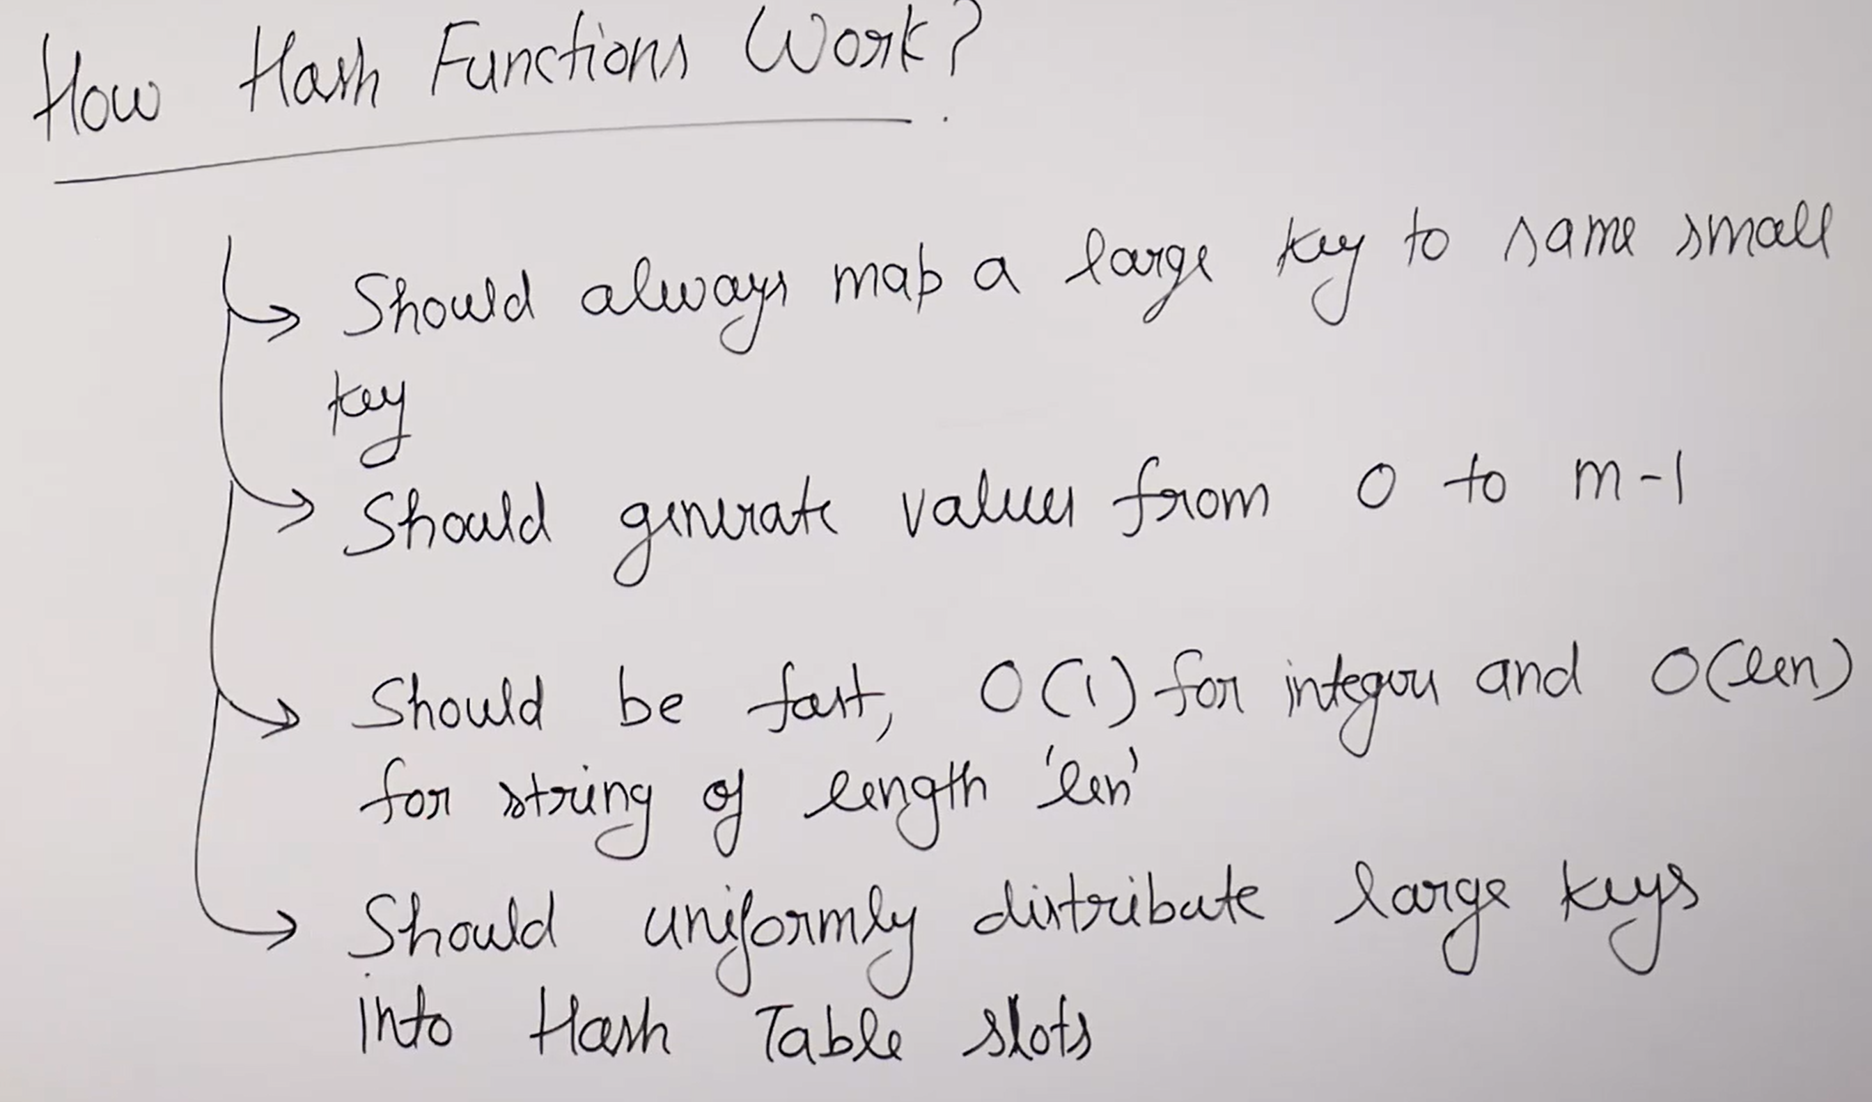
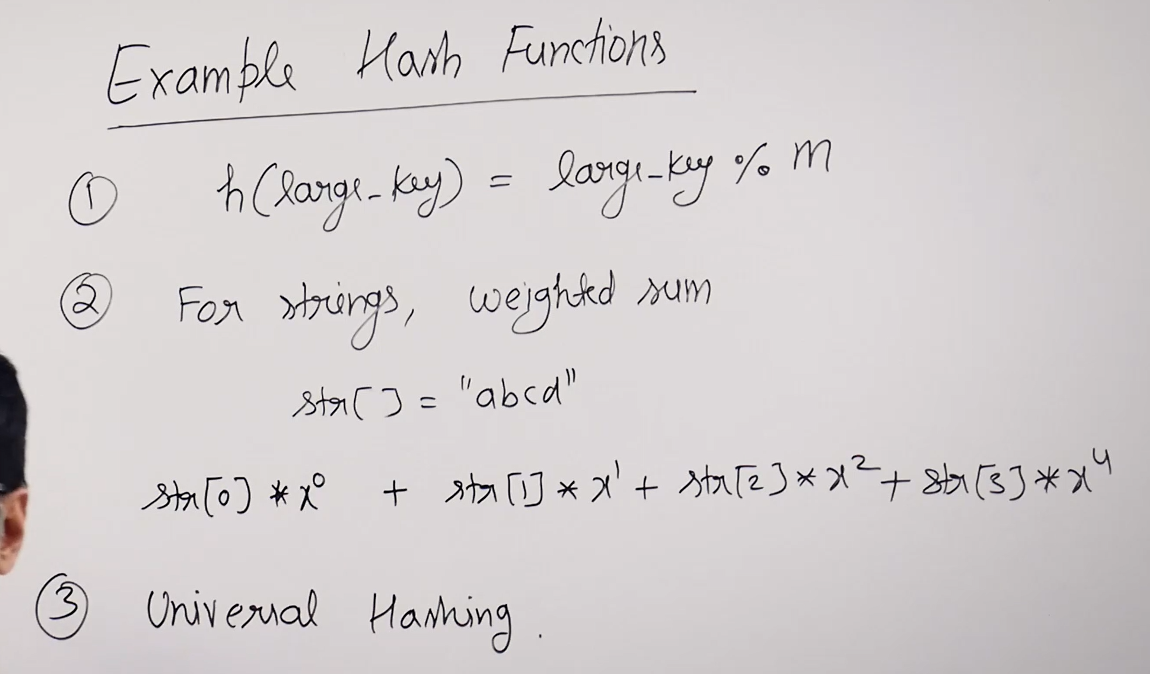
For the first function we mostly avoid the powers and choose the prime numbers.


